**configMobile Visit Website with research on Google**

We have two configuration files (txt files):

1. domains.txt - file containing the URLs of websites of interest to visit

2. keywords.txt - file containing the keywords to search on Google

These files may change content over time.

I have to develop a software (RPA or other) in any technology (suggested by you) that takes data from the 3 configuration files in txt (explained above) and carries out in order:

1. open in incognito browsing mode a browser of your choice (random) between Firefox, Chrome, Opera and Safari (already installed on the PC that will run the script)

2. activate the developer mode and then activate the device mode, and choose one from those in the list.

3. Visit the site www.google.com, avoiding blocks such as Acceptance of Consent or Use of Apps

4. Perform a search for one of the keywords within the appropriate configuration file (always random choice) avoiding any anti-spam checks by Google

5. Navigation and control from the resulting SERP, searching among the results those belonging to one of the websites in the configuration file provided.

6. If I find a link to one of the websites provided in the SERP, I click on it and navigate to it.

7. If I don't find it in the first 100 Google results, then perform a direct visit to one of the URLs (always chosen randomly from those provided) always from the list of URLs provided in the configuration.

8. Each visit must last between 100 and 200 seconds (also here the number of seconds chosen randomly)

9. Each visit must also include scrolling the page to the bottom at regular intervals, as if simulating reading the article.

10. Provide the possibility of clicking on certain coordinates of the screen or on elements identifiable through a possible last configuration file (to be defined) that contains for example the css classes of the elements on the page to be clicked.

11. After the visit and the clicks, it is necessary to close the browser.

12. The script must be launched via an executable or by clicking on an icon placed on the desktop

**WARNING**: make sure that the visits are made with a mobile device emulator. The goal is that these visits are tracked in Google Analytics and other similar tools, such as visits from different MOBILE devices

The script must run on a virtual machine in VIRTUALBOX with the following characteristics.

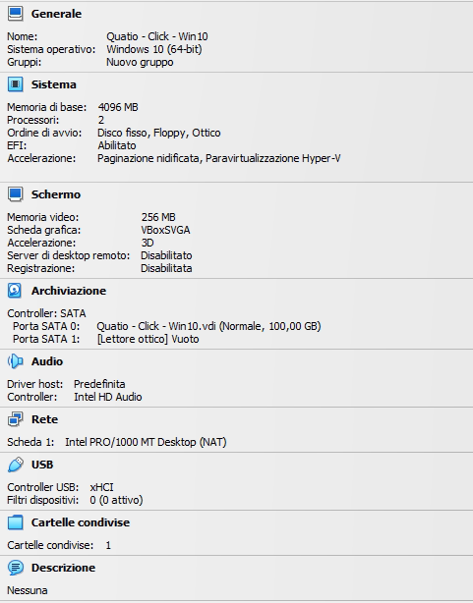

Have good work :D